* 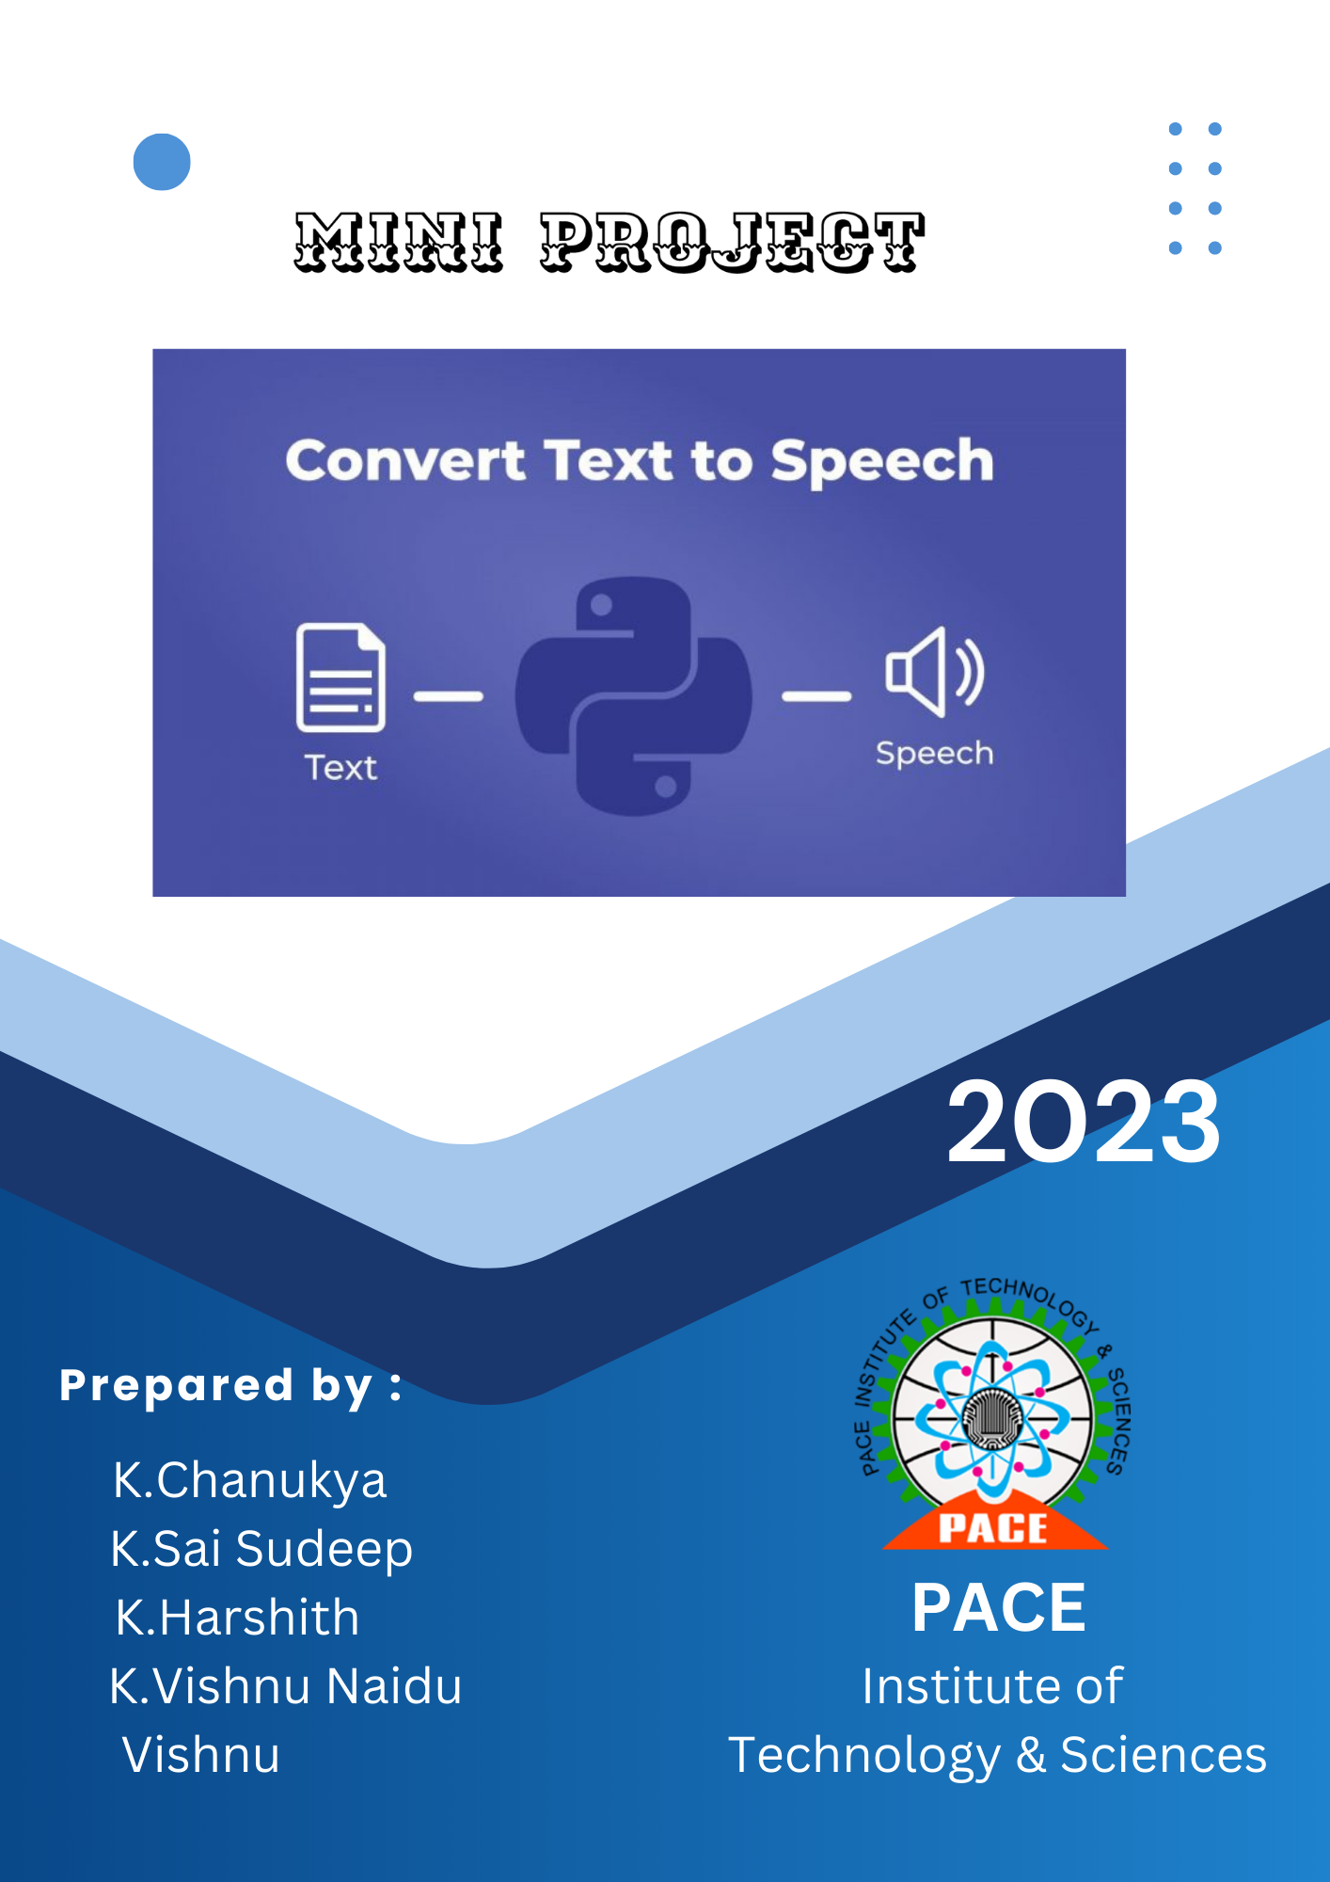

**Converting Text to Speech in Python with gTTs API**

**Abstract:**

The field of Natural Language Processing (NLP) has witnessed substantial advancements in recent years, with Text-to-Speech (TTS) conversion standing as a prominent application. TTS technology involves the transformation of written text into spoken language, enabling computers to generate human-like speech patterns. This abstract explores the implementation of TTS conversion using Python, a versatile and widely adopted programming language.

Python offers a range of libraries and frameworks that facilitate TTS conversion, making it accessible to developers and researchers alike. One popular library, such as the "gTTS" (Google Text-to-Speech) package, connects with Google's TTS API, enabling seamless text-to-speech synthesis. Additionally, "pyttsx3" provides an offline TTS experience by interfacing with various speech engines available on different platforms.

The abstract covers the basic workflow of TTS conversion using Python, which typically involves text preprocessing, feature extraction, and synthesis. Preprocessing steps include text cleaning, normalization, and tokenization to enhance the accuracy and naturalness of the generated speech. Feature extraction involves converting linguistic information into acoustic features, often using methods like Mel-Frequency Cepstral Coefficients (MFCCs).

Furthermore, the abstract touches upon the significance of speech synthesis models, including concatenative, formant-based, and neural TTS models. The emergence of neural TTS models, such as WaveNet and Tacotron, has notably improved the quality and expressiveness of generated spe ech. These models leverage deep learning techniques to capture complex linguistic nuances, resulting in more human-like and contextually relevant speech.

In conclusion, Python has become a pivotal tool for implementing TTS conversion due to its accessibility and robust ecosystem. The abstract highlights the key steps involved in TTS synthesis and introduces various Python libraries that streamline the process. As TTS technology continues to evolve, Python's role in enabling developers to create sophisticated and lifelike speech synthesis applications remains paramount

.

**Introduction:**

Text-to-Speech (TTS) technology is a fascinating application of Natural Language Processing (NLP) that converts written text into spoken language. By utilizing TTS, computers can generate human-like speech, making interactions with machines more intuitive and accessible. Python, with its extensive libraries and user-friendly syntax, has become a preferred choice for implementing TTS systems.

This introduction provides an overview of the TTS process using Python, highlighting its significance, applications, and key components.

**Importance of TTS:**

Text-to-Speech technology bridges the gap between written language and auditory communication. It has a wide range of applications, from aiding visually impaired individuals in consuming textual content to enhancing user experiences in navigation systems, virtual assistants, e-learning platforms, and entertainment media.

**Basic TTS Workflow:**

The TTS conversion process involves several stages:

Text Preprocessing: The input text is cleaned, normalized, and tokenized to improve the accuracy of speech synthesis. This step handles punctuation, capitalization, and special characters.

Feature Extraction: Linguistic features are extracted from the text to guide the generation of speech. Acoustic features, such as phonemes, prosody, and timing information, are essential for creating natural-sounding speech.

**Synthesis:**

The extracted features are used to generate speech sounds. This process can employ various techniques, including concatenative synthesis, formant synthesis, and neural network-based synthesis.

**Python Libraries for TTS:**

Python offers multiple libraries for TTS implementation, making the process accessible to developers:

gTTS (Google Text-to-Speech): This library interfaces with Google's TTS API, enabling users to generate speech in multiple languages and styles.

**pyttsx3:**

This library supports offline TTS using different speech engines available on various platforms.

**Speech Recognition:**

While primarily focused on speech recognition, this library can also be used to synthesize speech using text.

**Advanced TTS Models:**

The evolution of TTS technology has introduced advanced models that produce more natural and expressive speech. Neural TTS models, such as Tacotron and WaveNet, leverage deep learning techniques to capture intricate linguistic nuances and context, resulting in high-quality speech synthesis.

Text-to-Speech in Python empowers developers to create applications that enhance accessibility and user experience through spoken language. Whether for assisting visually impaired individuals, building interactive virtual assistants, or revolutionizing entertainment media, TTS showcases the remarkable intersection of NLP and Python programming. This introduction serves as a stepping stone for diving deeper into the world of TTS and its implementation using Python.

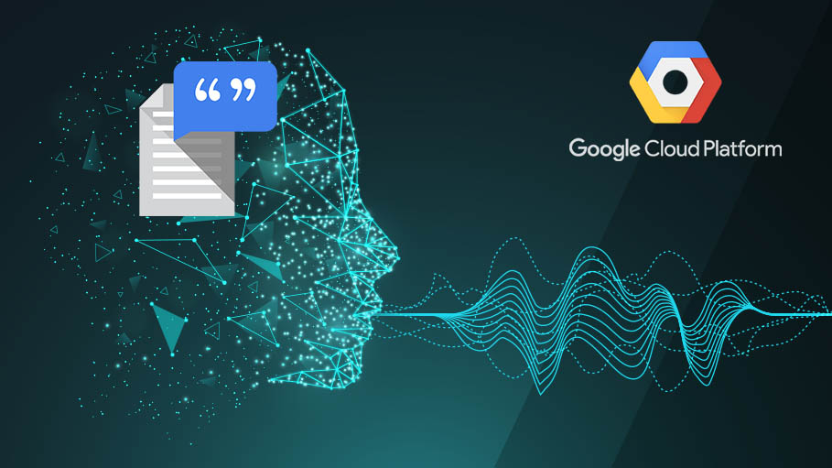

**Software and Hardware Requirements:**

**Hardware Requirements:**

* Normal Computer system with basic hardware configuration.

**Software Requirements:**

* Python IDLE (latest version)
* Media player in the system
* Install gtts package in python
* Install tkinter package in python

**Converting Text to Speech in Python with gTTs API**

In this project we are converting the speech given by the user into speech format by gTTs API in python.

**What is gTTs API ?**

gTTS, or "Google Text-to-Speech," is a Python library and an interface to the Google Translate API that allows you to convert text into spoken language. With gTTS, you can generate speech output from a given text input in various languages and even control the speech's speed and language accent. This library is particularly useful for applications that require converting text into speech, such as audiobook creation, voiceovers for videos, accessibility features, and more.

Here's how gTTS works:

**Installation:**

To use gTTS, you need to have Python installed on your system. You can install the library using the following command:

pip install gTTS

**Importing the Library:**

After installation, you import the gTTS library into your Python script using an import statement:

from gtts import gTTS

**Text-to-Speech Conversion:**

Once imported, you can use the gTTS class to create a gTTS object. You pass the text you want to convert to speech as an argument to the constructor:

text = "Hello, this is a test."

tts = gTTS(text)

**Language and Speed:**

You can customize the language and speech speed using optional parameters:

tts = gTTS(text, lang='en', slow=False) # English language, normal speed

**Generating Speech:**

After creating the gTTS object, you can generate the speech audio using the save() method and providing a filename:

tts.save("output.mp3")

This will create an audio file (e.g., output.mp3) containing the speech.

**Playing or Using the Speech:**

You can play the generated speech using your preferred audio player or incorporate it into your application. For example, you might use the playsound library to play the audio file:

import playsound

playsound.playsound("output.mp3")

That's the basic workflow of using gTTS. Under the hood, gTTS sends the input text to the Google Translate API, which converts the text to speech and then returns the generated audio. It's important to note that gTTS requires an active internet connection because it relies on Google's online services for the text-to-speech conversion.

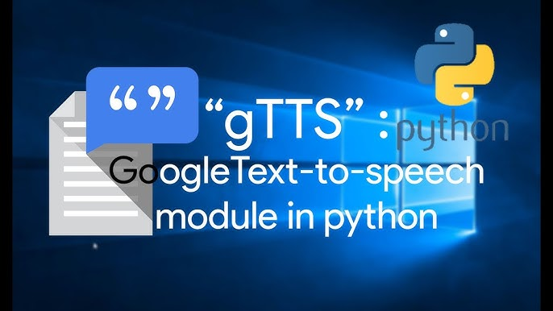

**Disadvantages:**

* gTTS is unable to read and convert the text into speech of large files, it has a certain limit.

**Source code of the Project**

from tkinter import *

from gtts import gTTS

import os

def test1():

    #label

    Label(root, text ='Enter the text', font ='Times 15 bold', bg ='White').place(x=222,y=180)

    ##text variable

    Msg = StringVar()

    #Entry

    entry_field = Entry(root, textvariable=Msg, width='84')

    entry_field.place(x=20, y=220)

    ###################define function##############################

    def Text_to_speech():

        Message = entry_field.get()

        speech = gTTS(text=Message)

        speech.save('DataFlair.mp3')

        os.system('DataFlair.mp3')

    def Exit():

        root.destroy()

    def Reset():

        Msg.set("")

    #Button

    Button(root, text="PLAY", font='times 15 italic', command=Text_to_speech, width=5).place(x=40, y=260)

    Button(root, text='EXIT', font='times 15 italic', command=Exit, bg='Red1').place(x=245, y=260)

    Button(root, text='RESET', font='times 15 italic', command=Reset).place(x=420, y=260)

def test2():

    #label

    Label(root, text='Enter the file name', font='Times 15 bold', bg='White').place(x=200, y=180)

    ##text variable

    Msg = StringVar()

    #Entry

    entry_field = Entry(root, textvariable=Msg, width='84')

    entry_field.place(x=20, y=220)

    ###################define function##############################

    def Text_to_speech():

        z = entry_field.get()

        q = z + ".txt"

        f = open(q, "r")

        input_text = f.read().replace("\n", " ")

        speech = gTTS(text=input_text)

        speech.save('DataFlair.mp3')

        os.system('DataFlair.mp3')

    def Exit():

        root.destroy()

    def Reset():

        Msg.set("")

    #Button

    Button(root, text="PLAY", font='times 15 italic', command=Text_to_speech, width=5).place(x=40, y=260)

    Button(root, text='EXIT', font='times 15 italic', command=Exit, bg='Red1').place(x=245, y=260)

    Button(root, text='RESET', font='times 15 italic', command=Reset).place(x=420, y=260)

root = Tk()

root.geometry('550x600')

root.resizable(0,0)

root.config(bg='cyan2')

root.title("Insane's - TEXT_TO_SPEECH")

##heading

Label(root, text='TEXT_TO_SPEECH', font='times 20 bold', bg='gray79').pack()

Label(root, text='Insane', font='times 15 bold', bg='ghost white').pack(side=BOTTOM)

Button(root, text='Want to Read Text', font='times 15 italic', command=test1, bg='steelblue1').place(x=200, y=70)

Button(root, text='Want to Read File', font='times 15 italic', command=test2, bg='steelblue1').place(x=200, y=130)

#infinite loop to run program

root.mainloop()

**Working of the Program**

* Installs tkinter,gTTs and OS packages.

from tkinter import *

from gtts import gTTS

import os

* Gives choice to select whether we want to read a text or read text file.

root = Tk()

root.geometry('550x600')

root.resizable(0,0)

root.config(bg='cyan2')

root.title("Insane's - TEXT_TO_SPEECH")

#heading

Label(root, text='TEXT_TO_SPEECH', font='times 20 bold', bg='gray79').pack()

Label(root, text='Insane', font='times 15 bold', bg='ghost white').pack(side=BOTTOM)

Button(root, text='Want to Read Text', font='times 15 italic', command=test1, bg='steelblue1').place(x=200, y=70)

Button(root, text='Want to Read File', font='times 15 italic', command=test2, bg='steelblue1').place(x=200, y=130)

* If we selected to read text, it gives the entry field to take input as text from the user and displays the of play, eit and reset on the window.

def test1():

    #label

    Label(root, text ='Enter the text', font ='Times 15 bold', bg ='White').place(x=222,y=180)

    ##text variable

    Msg = StringVar()

    #Entry

    entry_field = Entry(root, textvariable=Msg, width='84')

    entry_field.place(x=20, y=220)

    #Button

    Button(root, text="PLAY", font='times 15 italic', command=Text_to_speech, width=5).place(x=40, y=260)

    Button(root, text='EXIT', font='times 15 italic', command=Exit, bg='Red1').place(x=245, y=260)

    Button(root, text='RESET', font='times 15 italic', command=Reset).place(x=420, y=260)

* Now it converts the text into speech in mp3 format and saves the audio file in the system, if we click on the play button it plays the audio in any media player in the system or if we click reset it erases all the text given and if we click on the exit button, it exists from the window and terminates the program.

def Text_to_speech():

        Message = entry_field.get()

        speech = gTTS(text=Message)

        speech.save('DataFlair.mp3')

        os.system('DataFlair.mp3')

    def Exit():

        root.destroy()

    def Reset():

        Msg.set("")

* If we selected to read a text file, it shows the entry field to take the file name as the input from the user. And shows the play,reset and exit options.

Label(root, text='Enter the file name', font='Times 15 bold', bg='White').place(x=200, y=180)

    ##text variable

    Msg = StringVar()

    #Entry

    entry_field = Entry(root, textvariable=Msg, width='84')

    entry_field.place(x=20, y=220)

    #Button

    Button(root, text="PLAY", font='times 15 italic', command=Text_to_speech, width=5).place(x=40, y=260)

    Button(root, text='EXIT', font='times 15 italic', command=Exit, bg='Red1').place(x=245, y=260)

    Button(root, text='RESET', font='times 15 italic', command=Reset).place(x=420, y=260)

* now it opens and reads the file and converts text in the file into mp3 format and saves the audio file in the system. If we click on the play button it plays the audio in any media player in the system or if we click reset it erases the file name given and if we click on the exit button, it exists from the window and terminates the program.

And this is how the code works.

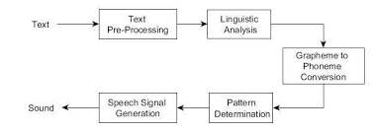

**Note:**

* if we want to run program properly we want save both files of the python program and text file in a same folder and in same directory while we are selected to convert a text file into speech. Otherwise the programs shows an Error.
* The program takes few seconds of time to read the file, so we want to wait to get the output.
* Some times it can’t read some because they are large files. gTTS has a limitation of reading text in files.

**Outputs**

* **While reading a text**

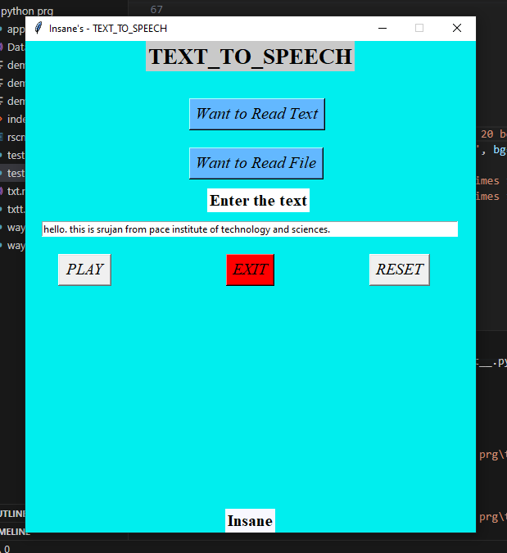

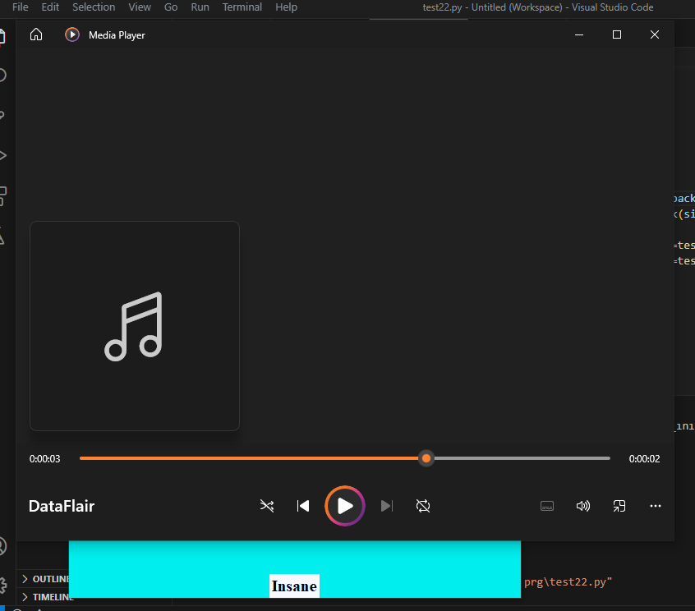**While**

* **reading a text file.**

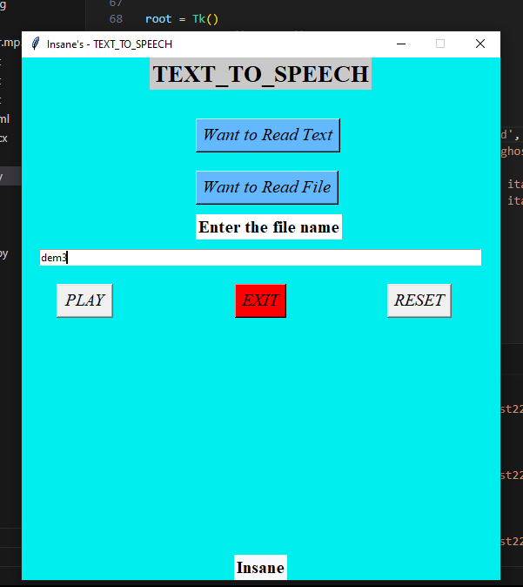

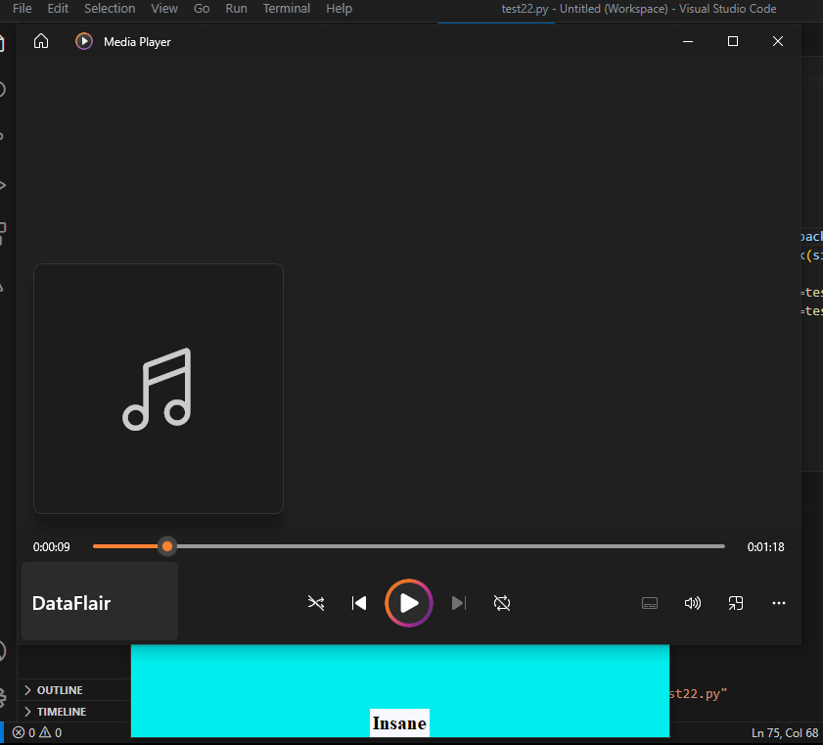

**Extensions:**

* we can add language recognition module,language conversion module to give input in different language and we can convert that input into speech into our preferred language.
* We can also use TTS API’s for better pronunciation of words in the text.

**Conclusion:**

In conclusion, the integration of text-to-speech functionality into Python applications using the gTTS library opens up a wide range of possibilities and opportunities for enhancing user experiences, accessibility, and content creation. By harnessing the power of gTTS, developers can easily transform textual information into spoken words, making information consumption more versatile and engaging. Here are some key takeaways and concluding thoughts:

**Enhanced Accessibility:**

The gTTS library empowers developers to create applications that are more inclusive and accessible to users with visual impairments. By converting textual content into speech, users who rely on auditory cues can interact with applications and content more effectively.

**Audiobook Creation and Voiceovers:**

With gTTS, developers can automate the process of creating audiobooks or adding voiceovers to videos. This can significantly reduce the time and effort required for content creation in multimedia projects.

**Interactive Applications:**

Text-to-speech capabilities can enhance interactive applications by providing real-time feedback, guidance, and instructions through speech. This is particularly useful in educational applications, language learning tools, and interactive tutorials.

**Multilingual Support:**

The ability to specify different languages and accents allows developers to cater to diverse audiences across the globe. This flexibility enables the creation of applications that can effectively communicate with users in their preferred language.

**Customization and Personalization:**

Developers can fine-tune the speech output by adjusting parameters such as speed and language. This level of customization ensures that the generated speech aligns with the application's tone and style.

**Consideration for Limitations:**

While gTTS offers remarkable capabilities, it's important to acknowledge its limitations, such as character limits, potential network dependencies, and the need for an internet connection. Developers should design applications that gracefully handle these constraints.

**Integration in Various Domains:**

The versatility of gTTS allows for its integration in various domains, including education, entertainment, customer support, and more. Exploring innovative ways to incorporate text-to-speech capabilities can lead to novel and valuable applications.

In essence, gTTS serves as a bridge between text and speech, enriching applications with auditory interactions and experiences. As technology continues to advance, the seamless integration of text-to-speech functionality has the potential to redefine how users engage with digital content. By harnessing the capabilities of gTTS, developers can create more inclusive, informative, and engaging applications that cater to a diverse range of users and scenarios.

**Summary:**

Text-to-speech (TTS) technology in Python offers a powerful way to convert written text into spoken language. The gTTS (Google Text-to-Speech) library, an interface to the Google Translate API, makes this process seamless and accessible. With a focus on simplicity and effectiveness, gTTS empowers developers to integrate speech synthesis into their applications with ease.

Upon installation, gTTS provides a direct pathway to generating speech from text. Using the gTTS class, you can create a gTTS object by providing the input text as an argument. This object encapsulates the desired text for conversion. Moreover, gTTS allows customization of the language and speech speed, enabling precise control over the auditory output.

Language support is diverse, accommodating a multitude of languages and accents. Developers can specify the desired language code, ensuring accurate and culturally relevant speech synthesis. Additionally, adjusting speech speed facilitates comprehension, tailoring the output to suit various contexts and audiences.

Once the gTTS object is prepared, speech synthesis is achieved through the save() method. This generates an audio file, typically in the MP3 format, that encapsulates the spoken rendition of the input text. This file can be utilized in numerous ways, such as integration into multimedia projects, audiobook creation, and enhancing user experiences by adding voice feedback to applications.

The gTTS library embraces simplicity without compromising functionality. With its concise workflow, developers can swiftly convert text to speech and harness the generated audio for their purposes. By bridging the gap between written and spoken language, gTTS offers a practical solution for a variety of applications. It enhances accessibility by providing an alternative way to access textual information, particularly benefiting visually impaired individuals.

However, it's essential to acknowledge that gTTS relies on an active internet connection, as it communicates with Google's servers for speech synthesis. Moreover, while gTTS excels in generating speech from smaller texts, larger texts may require additional handling, such as chunking, due to character limits imposed by the service.

In conclusion, gTTS revolutionizes text-to-speech capabilities in the Python programming ecosystem. Its seamless integration with the Google Translate API, coupled with straightforward customization options, empowers developers to transform text into impactful auditory experiences. Through gTTS, the world of spoken language converges with the realm of code, opening avenues for innovation in multimedia, accessibility, and application development.

**References:**

<https://codewithcurious.com/projects/convert-text-to-speech-using-python/>

<https://data-flair.training/blogs/python-text-to-speech/amp/>

